Name ______________________________________________ Date ___________________

Typed Document Information Packet

In the following pages, you will find a tutorial to guide you in typing work to be turned in for credit in this class. This guide will include a sample paper formatted appropriately, a sample paper formatted incorrectly (which you will be putting into the correct format during class), and a few instructions with screen shots for you to use to help guide you in using Microsoft Word to make these adjustments.

As we review the following pages, it is expected that you will take the appropriate notes to keep you informed. This tutorial is for typing in Microsoft Word. You may choose to write typed assignments in Google Documents and if so, the same requirements for formatting apply.

If you do not have a computer with Microsoft Word at home, you must correctly format it in Microsoft Word before turning it in to me. To do this, you must either e-mail it to yourself or save it to a USB drive and bring it to a computer with Microsoft Word PRIOR TO CLASS, and format it correctly using Microsoft Word. I will take significant credit off of any assignment that is turned in to me in the incorrect formatting, including but not limited to e-mailing a paper in the body of the e-mail or saving a paper in Notepad and e-mailing that file to me. You may also NOT simply share a Google Document with me, but instead must save it and send it to me as a separate document.
John Adams

Post World War II
Mrs. Levine
September 15, 2015
The Title of the Paper
The first line of every paper should be indented by pressing the tab key. As you begin to write, you should start broad, providing an introduction to your topic, and then end your introduction paragraph with your thesis statement. While this paragraph is only a few sentences, each paragraph should be between 5 and 8 sentences.
Each paragraph should be indented on the first line. The body paragraph, or paragraphs, should focus on the details of your topic to support your thesis statement. The end of each paragraph should have a transitional sentence into the next body paragraph, or into your closing paragraph.
Your closing paragraph should again be indented on the first line and should begin with your thesis statement. Summarize each of the main points in your paper, and then end with a broad, but not overly conclusive, statement.
Summer Vacay
My summer vacation was awesome. This summer I spent almost every day at the beach and had the best time ever. I made the most of my summer and used it to relax and not think about school. This past weekend was Labor Day weekend and I got ready to come back to school. I went shopping for some new clothes and hung out with my friends every day. Now school is back and I can’t wait for the weekend to hang out with my friends again.
This weekend, I will also do some homework though probably since it is the beginning of the year and I have to get back into school mode. I also have to go to a family party this weekend so between that and hanging out with friends so it’ll be a pretty busy weekend. This summer was great and I am excited about this school year and making new memories with my friends before high school is over.

BY: John Adams
So, you know the basics: Times New Roman font, size 12 font, left-aligned and double-spaced with 1 inch margins. Also, the proper heading must be used and each paragraph must be indented. After typing your paper, you must use spell check and grammar check before turning it in for credit. Here are screen shots to guide you through your paper formatting…

FONT

Choose your font in the top left corner. Always make sure you have selected Times New Roman when typing an academic assignment.

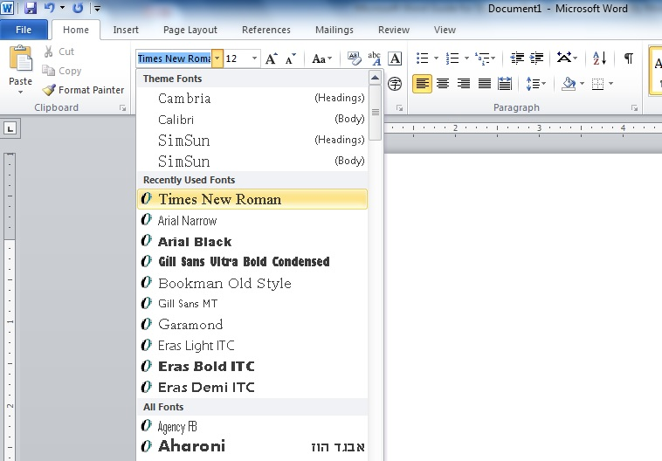

FONT SIZING

To the right of the font type selection, is the sizing. Always make sure that you have selected size 12 when typing an academic assignment.

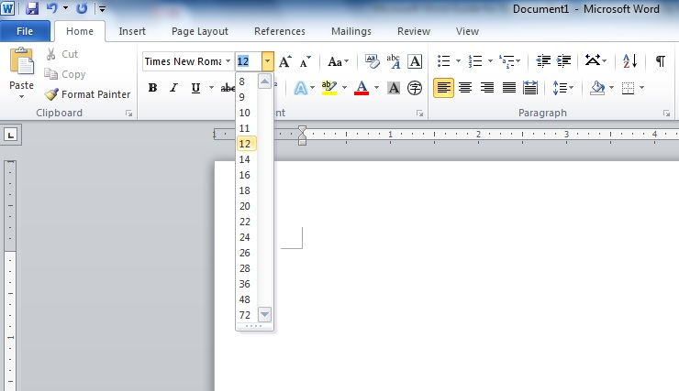

Below the font type and sizing choices are the bolding, italicizing and underlining options. Only use these when required to do so for proper citation. Do not use them otherwise.
ALIGNMENT

To the right of the font options, is the paragraph options area. Always make sure that you have selected left alignment when typing papers. The only thing that should be aligned to the center is the title of your assignment.

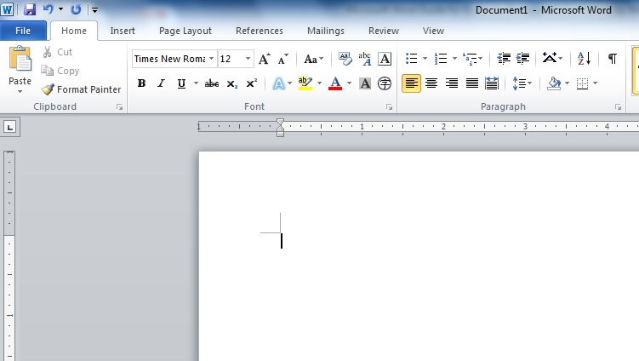

DOUBLE-SPACING

To the right of the alignment options, is the spacing option. Always make sure that you have selected double-spacing when typing papers.

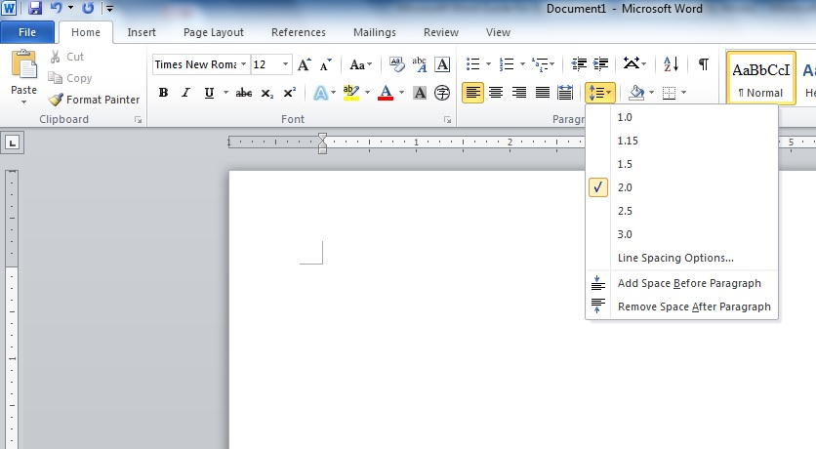
MARGINS

To select the proper margin size, you must click on the Page Layout tab at the top of the page. Your margins should always be 1” on all sides.

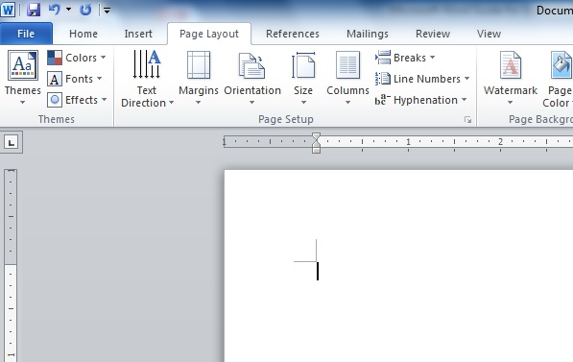

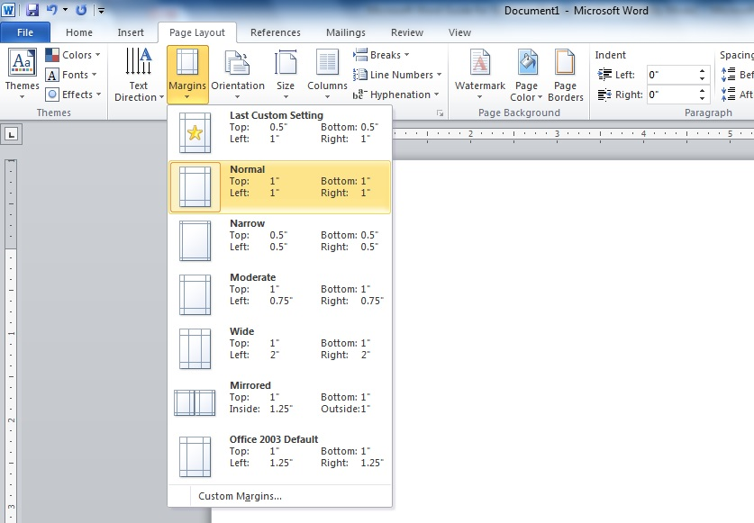

HEADING

Your heading should always be formatted as shown here, with your name, the class name, the teacher name and the due date of the assignment placed in the upper left corner. This should always be double-spaced and followed by your title, which is always centered.

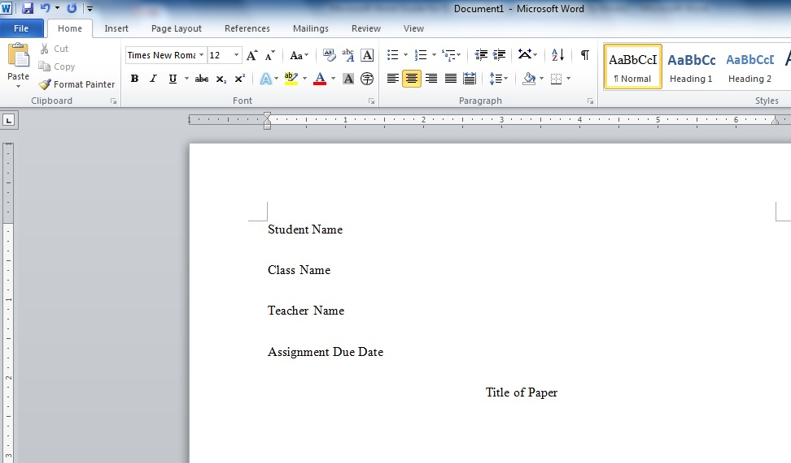

INDENTING

The first line of every paragraph in your writing should always be indented. In order to indent, locate the “Tab” key on the left side of your keyboard. It is located 3 keys down from the top left of the keyboard, and 4 keys up from the bottom left. Once indented, the first line of your writing will look as follows:

