Name: _____________________________________ Date: ________________ Period: ________

Marbury v. Madison (1803)
Directions: Read the passage below and answer the following questions.

In 1800, President John Adams ran to be re-elected as president, but he lost to Thomas Jefferson. During his last weeks in office, Adams appointed 58 members of his own party to fill government jobs created by Congress. Some of these men, who were appointed as judges, were referred to as the “midnight judges” because President Adams made these appointments on his last night as President. Each man would receive a paper commission that was signed and sealed. The commissions were prepared, but they were not sent before Adams left office. When President Jefferson took over, he ordered Secretary of State James Madison, to refuse to send these papers confirming the appointments. Those individuals would not be able to take office until they actually had their papers in hand. Many Republicans accused the Federalists of using unfair tactics to keep control of the courts.
One of these “midnight judges,” William Marbury, was upset. President Adams had appointed him to be justice of the peace of the District of Columbia. Marbury argued that he was entitled to the job and that the Judiciary Act of 1789 gave the Supreme Court original jurisdiction to issue a writ of mandamus, which is the type of court he needed. Marbury sued Madison. According to the Judiciary Act of 1789, only the Supreme Court could decide a case that was brought against a federal official. Therefore, the case of Marbury v. Madison was tried before the Supreme Court.

An Important Precedent

The Supreme Court ruled against Marbury. Chief Justice John Marshall wrote the decision, stating that the Judiciary Act was unconstitutional. The constitution, Marshal argued, did not give the Supreme Court the right to decide cases brought against federal officials. Therefore, Congress could not give the Court that power simply by passing the Judiciary Act.
The Supreme Court’s decision in Marbury v. Madison set an important precedent. It gave the Supreme Court the power to decide whether laws passed by Congress were constitutional and to reject laws that it considered to be unconstitutional. This power of the Court is called judicial review. Marshall’s decision gave more power to the Supreme Court. Today, judicial review remains one of the most important powers of the Supreme Court.
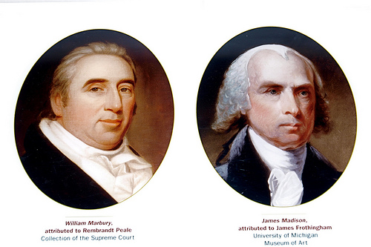

- What were the judges appointed by President John Adams referred to? Why were they known by this name?

_________________________________________________________________________________________________________________________________________________________________________________________________________________________________
- What did President Thomas Jefferson order Secretary of State James Madison to do?

_________________________________________________________________________________________________________________________________________________________________________________________________________________________________
- What did William Marbury do in response to Madison’s decision?

_________________________________________________________________________________________________________________________________________________________________________________________________________________________________
- What was stated in the Judiciary Act of 1789?

_________________________________________________________________________________________________________________________________________________________________________________________________________________________________
- Why did Chief Justice John Marshall declare the Judiciary Act unconstitutional?

_________________________________________________________________________________________________________________________________________________________________________________________________________________________________
- How did this decision set an important precedent?

_________________________________________________________________________________________________________________________________________________________________________________________________________________________________

