Life in China Under Emperor Shi Huangdi
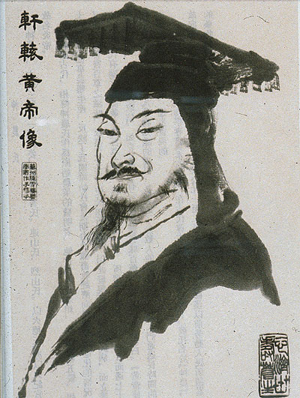
“Ouuggghhh!” Again, my bruised body banged against the side of the cart. I had nearly fallen asleep, but the road was a series of pits, ditches and rocks. Even if I had been riding in comfort, the road would have been a torment. The man in front of me groaned also, but he was unconscious. He resisted being taken, and his injuries were far worse than mine. Behind me, two more men were also bound and tied. Like the others who rode with me, my hands were tied above my head and attached to a long pole that traveled the length of the darkened, covered cart. I did not know what crime the other men committed; I only knew about myself. My name is Zhang Wei, and I was a scholar, a man of learning. I studied the writings of the great Chinese philosopher Confucius, and that is why I am going to be executed.

Allow me to give my tale a little bit of context. As I said, I am a scholar, as my father and grandfather were before me. Many of my ancestors were also scholars. I have lived my life in a small city near the Yellow River where I taught people to know for themselves what was wrong and what was wrong, as was taught by Confucius.

I remember well when our great divine emperor Shi Huangdi first came to power. From our small country of Chin, he created a great and powerful army. One by one he conquered the warring states of our land, and so we became one land known as China. But he was brutal and ruthless. When his mother plotted agianst him, he had her banished. Her husband was then torn apart by having ropes tied to his limbs, and the ropes in turn tied to horses. He was torn to pieces. His mother’s children to this man, aged four and six, were strangled. Everyone was horrified by these stories, but the emperor was all powerful and most, including muself, were too frightened to speak out against him.

Despite his horrific brutality, for many years his rule was a great benefit to all. No longer were there constant wars in the land because with a unified land, there was no need for wars. The emperor also repaired and built many roads and bridges, bringing the land together. Trade flourished and many Chinese became wealthy and prosperous. Before Emperor Shi Huangdi, each area of China seemed to have a different writing system, different words for the same things, and many different laws. All of this ended with the coming of the emperor. Emperor Shi Huangdi unified the writing system, the language and the law. There was peace and justice in the land and China was one and prosperous. It seeemed that our nation would forever rise in greatness.
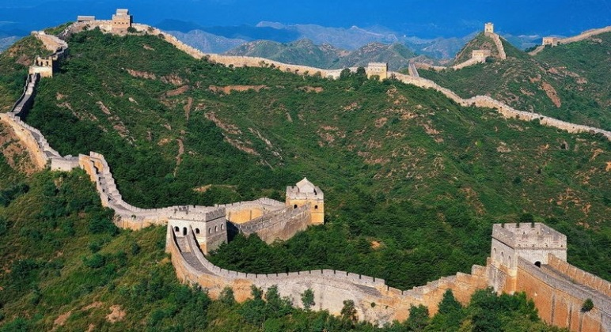
But, the emperor changed. The optimism that we had all once felt slowly turned to terror. He began forcing the people to work on his projects. Fathers, brothers, and husbands were plucked up by his men and taken to work on his majesty’s projects. Millions of men were taken to build his Great Wall, but many never returned home. The Wall was a wall of tears as hundred of thousands of innocent men were worked to their deaths and buried in the wall.

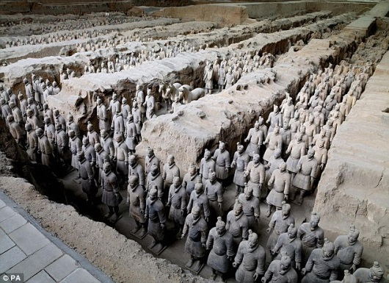
Later, the men who were not taken to work on the Wall were forced to work on his great tomb. Hundred of thousands more men were forced to build a giant earthen pyramid and thousands more to make his Terra Cotta warriors to protect the emperor in death.

All of China suffered under the emperor’s projects. With so many men forced to work, the land had to be worked and farmed by the women and children. If there was any hardship – flood or drought – those families could not keep up with the work that needed to be done. Starvation and famine stalked the land. Whereas once many families credited the emperor for bringing peace and making them rich, now they suffered and starved, but they dared not speak a word against him.

The emperor’s prime minister, Lao Tzu, began a practice called Legalism. Under Legalism, the law was supreme and no one could disobey the law without being executed. The lucky ones were taken away to work on projects and worked to the death. Under Legalism, neighbors and even family members were told to report any talk of disobedience or rebellion towards the emperor. The penalty for not reporting was death for both the person unwilling to report, and their entire family. Further, reporting rebellious talk was often rewarded. Some starving families gave into this temptation and turned in individuals who had not spoken out against the emperor. Not only had the emperor turned on his people, but he was making his people turn on one another. The land suffered, China suffered, and something had to be done.

Confucius wrote, “To know what is right and not do it, that is cowardice.” For too many years, I watched and stayed silent as our land and people found themselves consumed with the laws and madness of the emperor. I had been a coward and I shamed myself before my ancestors and so I decided to take a stand. When the prime minister outlawed the writings and teachings of Confucius, I refused his orders to hand over the books for burning. Instead, I paid a man to have them carried away and buried safely, away from the prime minister’s men. I knew what I had done was illegal, but it was right.

Alas, the man that I had trusted to help me was dishonest and he did not do as he had primised. Instead, he took my money and delivered the books to a government official to report me for my crimes. Yesterday, the emperor’s men arrived at my home and without speaking a word, they savagely beat me. Then they tied, gagged, and bound me in this cart, all the while tell me that my family would also be killed for my disobedience to the emperor. I pray that their deaths are swift. Why did this happen to me? Why did China become overrun by a madman? Why didn’t the people stand up to him? Why did I wait so long to speak out?

As I suffer in this cart, jostling down this road built by the emperor, I have few answers to my questions. I know that I am being taken to die, but I do not know how. Leave me to mourn the death of my family, as I know that I will be joining them soon.

The man in this story was later unloaded, and along with hundred of other Confucian scholars, buried alive. Confucius taught to do what was right, but the emperor taught to do what he said was right. What would you have done? Would you have done was was right and stood up to the madman? Or taken the cowardly way out to save yourself and your family?
Life in China Under Emperor Shi Huangdi Graphic Organizer

Writing Prompt: Was Shi Huangdi a great emperor of China or a monster? After reading the story Life in China Under Shi Huangdi, write a 5-paragraph essay that addresses this question and support your position with evidence from the text, as well as outside sources if needed.
Be sure to acknowledge competing views within your essay.

First, use this organizer to place evidence on both sides.

Great Emperor | Monster

Then, write a five-paragraph essay – with introduction, three body paragraphs, and a conclusion – asserting whether Shi Huangdi was a great emperor or a monster.

