Name: __________________________________________ Date: __________________

Unit Eight: European Middle Ages Notes Outlines

Date: __________________

Our study of the European Middle Ages will start with the examination of the early European Middle Ages, and move throughout the next 900 years as we take a closer look at the social, political and economic system of the time and how the Church held power throughout Europe. We will then move into our study of the late European Middle Ages as we focus on the development of England, as well as two great disasters in European history – war and disease. We will study these in the following sections:

- Introduction & Dark Ages
- Feudalism in Europe
- Age of Chivalry
- Power of the Church
- Development of England
- The Hundred Years’ War and the Plague

Section One: Introduction & Dark Ages

Date: __________________

DARK AGES | MIDDLE AGES

Expanding Influence of the Church

The Christian Church became an important __________________________________________ _____________________________________________________________________ in Europe.

European Empire Evolves

Carolingians

CAROLINGIAN DYNASTY:

Charlemagne and the Holy Roman Empire

Charlemagne as Emperor

Section Two: Feudalism in Europe

Date: __________________

England in the Dark Ages

ANGLES:

Norman Conquest

NORMANDY:

Invasions in Western Europe

Viking Raids

FJORD:
Vikings as Traders

Feudalism Structures Society

LORD:

FIEF:

VASSAL:

European Feudal Pyramid

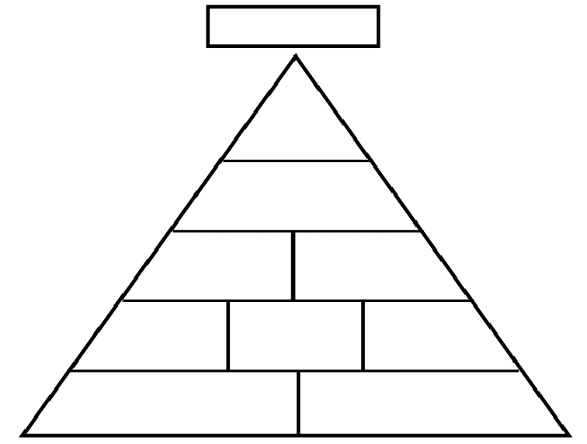

Well-Defined Social Classes

SERFS:

Manorialism

MANOR:

Self-Contained World

Harshness of Manor Life

TITHE:

Section Three: Age of Chivalry

Date: __________________

Warriors on Horseback

Code of Chivalry

CHIVALRY:

TOURNAMENT:

Literature of Chivalry

TROUBADOURS:
Women’s Role in Feudal Society

Section Four: Power of the Church

Date: __________________

Amid the weak central governments in feudal Europe, the Church emerged as a powerful institution. It shaped the lives of people from all social classes. As the Church expanded its political role, strong rulers began to question the pope’s authority. Dramatic power struggles unfolded in the Holy Roman Empire, the scene of mounting tensions between popes and emperors.

Far-Reaching Authority

Age of Faith

Influenced by the religious devotion and reverence for God shown by new monasteries, the pope began to reform the Church.

Reformers were distressed by 3 main issues:
1.
2.
3.
SIMONY:

Cathedrals – Cities of God

The Crusades

CRUSADE:
The Crusaders

First and Second Crusades

Perspectives of the Crusaders
INFIDEL:

Overview of the Other Crusades

RECONQUISTA:

Effects of the Crusades
The effects of the Crusades on the people who fought them were widespread, and often devastating. These are the 6 major effects of the Crusades:

Section Five: Development of England

Date: __________________

England’s Evolving Government

COMMON LAW:

Magna Carta

MAGNA CARTA:

The Model Parliament

PARLIAMENT:

Section Six: The Hundred Years’ War and the Plague

Date: __________________

Start of the Bubonic Plague

Impact and Effects of the Plague

Hundred Years’ War

Impact of the Hundred Years’ War

Both the French and British experienced major changes:

