Roanoke Island Mystery

(from http://totallyhistory.com/roanoke-island-mystery/)

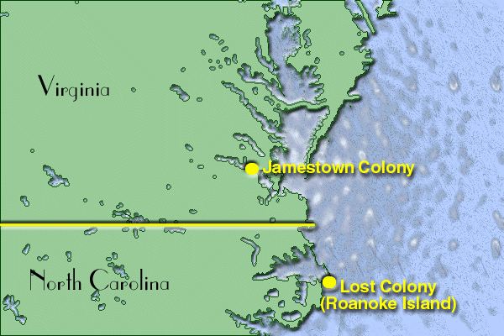

First Settlement

Roanoke Island is famous for having the first ever English colonial settlement in the New World. But what it is most famous for is how mysteriously these first English settlers disappeared after a short time. Some say that they were killed; others say that they hid; still others say that they were absorbed into the native tribes. These settlers inRoanoke Island, who mysteriously disappeared without a trace, are popularly referred to as

“The Lost Colony.”

While Jamestown was the first permanent settlement in the New World, Roanoke Island was host to English settlers even before the start of the 16th century. Roanoke Island is where the first child of English decent was born in the New World, and there had been many speculations as to what happened to the colony after that. King James I of England even made it a point to go on the first voyage toJamestown to search for the first colony in America.

The Return

It was in 1584 when the first group of English settlers made settlements in Roanoke Island. This first batch of settlers consisted of a hundred men, but the quickly abandoned their first settlement due to harsh weather conditions and their failure to keep a good relationship with the native tribes. After three years, the second batch of English settlers set foot on the island in July. After a month, the first English child was born in the New World. A week after Eleanor Dare’s child was born, his grandfather, Captain John White, set sail for England to bring them back food supplies and materials. What Captain White expected to be a short trip turned out to be a long stay in his motherland. The Spaniards attacked England, and there were many other unexpected events, and so he managed to return to Roanoke Island three years later.

A Mystery

What Captain John White saw was mysterious and utterly unbelievable. His daughter, Eleanor Dare, and his granddaughter, Virginia Dare, were nowhere to be seen! He saw no one from the English settlement he left three years ealier, and the place was bare of any signs of life as even the houses were nowhere to be seen. The letters “CRO” was sketched on a nearby tree and the word “Croatan” was found on a post, but even a visit to the Croatoan Indians gave him no answer as to where his family and the English colony had gone.
Some say that the colony was wiped out by a violent deadly storm, and it was easy to imagine that on an island. Others say that the settlers had been the subject of brutal attacks by nearby native tribes, to help prevent future colonization on the island. Others say that they had intermingled with and become absorbed into the native population, that they became so comfortable with living as natives that they ultimately decided not to return to the colony. The loss of more than a hundred people—consisting of 90 men, 17 women and 9 children—marks the mysterious end of the first ever attempt to establish a permanent settlement in the New World.

